

**L.J. INSTITUTE OF COMPUTER APPLICATIONS**

**Gujarat Technological University**

**(GTU)**

**PROJECT REPORT ON**

**Jobify**

**Jobify**

Guided By: Dr. Rinkal Sardhara

Group Number: 25

**Developed By:**

* Tanvi Gohel (205180686057)
* Dhyan Shah (205180686027)
* Heli Acharya (205190686054)

**Table of Contents**

1. Introduction ……………………………………………………………………………………………...
   1. Existing System…………………………………………………………………………...........
   2. Need for the New System………………………………………………………………………
   3. Objective of the new System…………………………………………………………………...
   4. Problem Definition……………………………………………………………………………
   5. Core Components……………………………………………………………………………..
   6. Project Profile…………………………………………………………………………………
   7. Assumptions and Constraints…………………………………………………………………
   8. Advantages and Limitations of the Proposed System………………………………………...
   9. Proposed Time Line Chart…………………………………………………………………….
2. Requirement Determination & Analysis………………………………………………………………….

2.1 Requirement Determination…………………………….…………………………………….

2.2 Targeted User…………………………………………………………………………………

2.2 Requirement Specification….………………………………………………………………...

1. System Design

3.1 Use Case Diagram…………………………………………………………………………….

3.2 Class Diagram…………………………………………………………………………………

3.3 Activity Diagram……………………………………………………………………………...

3.4 Data Dictionary………………………………………………………………………………..

3.5 User Interface Design…………………………………………………………………………

1. Development

4.1 Navigation……………………………………………………………………………….........

4.2 Client Side Validation……………………………………………………...…………………

4.3 Server Side Validation………………………………………………………,,………………

1. Testing

5.1 Test Plan & Testing Method…………………………………………………..………………

1. Implementation…………………………………………………………………………………………
2. Proposed Enhancements……………………………………………………………………………..…
3. Conclusion……………………………………………………………………………………………...
4. Bibliography…………………………………………………………………………………………….

Jobify

Introduction

In the early years of the twenty first century, it is computers and the Internet that have captured the public imagination, and found their way into not just the working environments, but increasingly into the domestic spaces. In this modern society, if we are not capable to cope up with these changes than we are not going to stand or survive anywhere in this technical world.

Today there is no place for errors, so as to make a system more effective and efficient we need such technology where error prone chances must be least. In the scenario of the assignment, we are required to develop a web-based application on Job Portal System.

In this time of recession where everyone, is either experienced or fresher, is in search for a job. Jobify can prove to be very helpful since it allows users of different profile to upload their CVs, search job on the basis of their qualification.

Every user can access Jobify for multiple jobs at a time. This is another job portal with an open environment for the job seekers and recruiters to meet on the same site and know about each other so that the right candidate is placed in a right company.

**1.1 Existing System**

There are few ways of traditional recruitment (OLD process) such as Employment recruitment agencies, job fairs, advertising in the mass media such as newspapers, advertisement in tv and radio, management consultants and many more.

Right now, in the World there are few like us who are providing online job portal, that you can upload CVs and communicate for the job.

As we have seen that job seekers are always seeking for exploring new jobs but sometimes there are few problems faced by them such as many of the jobs are not real, etc.

**1.2 Need for the New System**

The purpose of e-recruitment is to make recruiting processes more efficient and less expensive. And by using e-recruitment , HR managers can reach a larger amount of potential employees and speed up the hiring process.

This trait makes it easier for job seekers to decide on a specific career. Equally, Job Seekers get more job opportunity. And job seekers also get to communicate with well established companies.

**1.3 Objective of the new System**

Jobify that is to be developed provides the members with jobs information, online applying for jobs and information, get new job alerts. Jobify provides service to job applicants to search for working opportunities.

Jobify will allow company to establish one to one relationship with candidates. It will primarily focus on the posting and management of job vacancies.It also focus on filtering CVs .By posting job on Jobify the company promotes itself in front of a large audience.It helps to review and manage the resulting applications efficiently through the web.

Admin acts as a mediator between company and users.Admin will provide a platform for user to search for jobs and to explore jobs. Where as it will provide an interface to company to post jobs for job seekers..

**1.4 Problem Definition**

.

**1.5 Core Components**

**1. User**

* Registration: - User can Register.
* Login: - User can Login.
* Search job: - User can Search job.
* Upload CV: - User can upload CV.
* Apply: - User can apply for job.
* Contact:- User can contact admin through contact page form.
* Logout: - User can Logout.

1. **Admin**

* Admin Registration: - Admin can Register.
* Managing Visitors: - Admin track visitor to manage the website traffic.
* Logout: - Admin can Logout.

1. **Company**

* Company Login : - Company can Login.
* Manage Posts: - Company can Manage Posts.(I.e CRUD)
* Manage CVs: - Company can Manage CVs.
* Job Confirmation: - Company can confirm the job.
* Logout: - Company can Logout.

**1.6 Project Profile**

|  |  |
| --- | --- |
| Project Title | Jobify |
| Components/Module | Admin  User |
| Institute Name | LJ Institute of Computer Application |
| Duration | 4 Months |
| Project Internal Guide | Dr. Rinkal Sardhara |
| Front End | ASP.NET |
| Back End | Sql server management database |
| Operating System | Windows 10 |
| Team Member | IET-14 Tanvi Gohel (205180686057)  IET -50 Dhyan Shah (205180686027)  B-21 Heli Acharya (205190686054) |

**1.7 Assumptions and Constraints**

* **Assumptions**
* Every Web Site can not be trusted for providing resume.
* The user should have sufficient knowledge about company background..
* The job seekers should have internet connection and Internet server capabilities 24/7.
* A Website that offers “employers” job offers by their resumes are doing a favor.
* Any Website which has posted a privacy is one which you can trust.
* Your current employer will never find your resume online.
* **Constraints**
* There is no in person communication at the time of applying..
* User can be mistaken by company name..
* There are chances of selecting wrong candidate.

**1.8 Advantages and Limitations of the Proposed System**

* **Advantages**
* It is cost effective and easy to use.
* It is immediate (i.e It is fast than the traditional marketplace)..
* You can reach bigger audience.
* You can make job ad more dynamic
* Process Applications with customized work flow.
* It Publish jobs to numerous candidates with simple process.
* Company promotes itself by offering jobs among large audience.
* **Limitations**
* It can be difficult to measure their effectiveness.
* It can attract bad candidates.
* There is a lot of competition.
* It can affect communication.

**1.9 Proposed Time Line Chart**

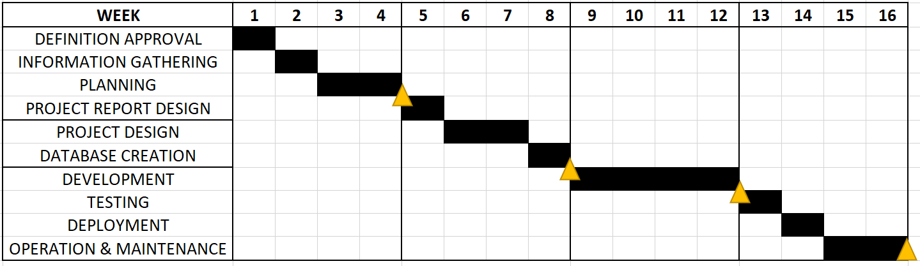

**Requirements Determination & Analysis**

**2.1 Requirement Determination**

Online recruitment, unlike conventional recruitment is fast acting, efficient and cost effective. Online recruitment varies from traditional recruitment in many ways. According to Coronas TT and Oliva M A (2005, p 88) the process of traditional recruitment consists of iterative concepts such as:

* Submission of job request and its approval.
* Recognition of recruitment needs.
* Applications or resume screening.
* Job posting.
* Job applications submission.
* Pre-employment screening.
* Interviewing and employment contract and job offers.

In online recruitment all the recruitment activities and practices are carried out by acquiring different electronic means to fill open positions efficiently and effectively. The process of online recruitment consists of several steps such as:

* Submission of applications by applicants directly into the database.
* Online self assessment or online pre-screening.
* Submission of job requisition.
* Online job posting.
* Approval of the requisitions of jobs through a database.
* Online search of database by job seekers.
* Online evaluation of applications or resumes.
* Online search of the applicant database for selection of candidates.
* Interviewing by recruiters or hiring managers.
* Online evaluation of applications or resumes.
* Online pre-employment screening and offer of employment contract or job offer online.

**2.2 Targeted Users**

Our Targeted Users are as follows:

* Visitors.
* Users.
* Company.

**2.3 Requirement Specifications (Software and Hardware)**

* **Hardware Requirement**
  + **Client-Side Tools**
    - Processor: Intel ®i5 Pentium 4
    - RAM: 8GB.
    - Hard Disk: 500 MB
  + **Server-Side Tools**
    - Processor: Intel ®i5 (minimum)
    - RAM: 8GB
    - Hard Disk: 500 MB Hard disk space (minimum)
* **Software Requirement**
* Operating System: Windows
* Front-end: Asp.NET
* Back-end: SQL
* Database-Technology: SQL server management database
* **Functional Requirements**
* Registration:
  + User can apply for job.
* Login:
  + Use logins to the system by entering valid user id and password for the job seeking.
* Logout:
  + After applying for job, User can logout.
* User-Interface:
  + The system has good user interface.
* Contact Us:
  + For contact with the room when you have problems or would like to know the information to be provided.
* **Non- Functional Requirements**
* Security
  + Provide the better security to all the user proposed system.
* Scalability:
  + Proposed system is easily scalable to the data.

**System Design**

**3.1 Use Case Diagram**

